UML Association vs. Aggregation vs. Composition
In UML diagrams, relationships are used to link several things. It is a connection between structural, behavioral, or grouping things. Following are the standard UML relationships enlisted below:
- Association
- Dependency
- Generalization
- Realization

Association
Association relationship is a structural relationship in which different objects are linked within the system. It exhibits a binary relationship between the objects representing an activity. It depicts the relationship between objects, such as a teacher, can be associated with multiple teachers.
It is represented by a line between the classes followed by an arrow that navigates the direction, and when the arrow is on both sides, it is then called a bidirectional association. We can specify the multiplicity of an association by adding the adornments on the line that will denote the association.
Example:
1) A single teacher has multiple students.
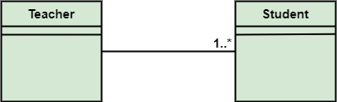
2) A single student can associate with many teachers.
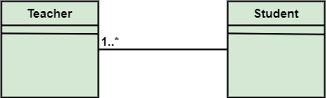
The composition and aggregation are two subsets of association. In both of the cases, the object of one class is owned by the object of another class; the only difference is that in composition, the child does not exist independently of its parent, whereas in aggregation, the child is not dependent on its parent i.e., standalone. An aggregation is a special form of association, and composition is the special form of aggregation.
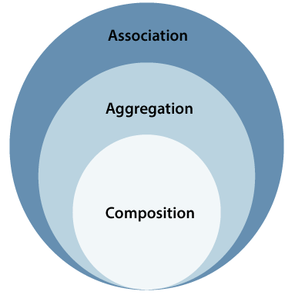

Aggregation
Aggregation is a subset of association, is a collection of different things. It represents has a relationship. It is more specific than an association. It describes a part-whole or part-of relationship. It is a binary association, i.e., it only involves two classes. It is a kind of relationship in which the child is independent of its parent.
For example:
Here we are considering a car and a wheel example. A car cannot move without a wheel. But the wheel can be independently used with the bike, scooter, cycle, or any other vehicle. The wheel object can exist without the car object, which proves to be an aggregation relationship.
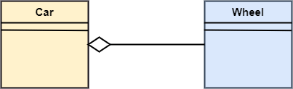

Composition
The composition is a part of aggregation, and it portrays the whole-part relationship. It depicts dependency between a composite (parent) and its parts (children), which means that if the composite is discarded, so will its parts get deleted. It exists between similar objects.
As you can see from the example given below, the composition association relationship connects the Person class with Brain class, Heart class, and Legs class. If the person is destroyed, the brain, heart, and legs will also get discarded.
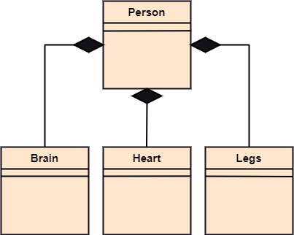

Association vs. Aggregation vs. Composition
Association | Aggregation | Composition
Association relationship is represented using an arrow. | Aggregation relationship is represented by a straight line with an empty diamond at one end. | The composition relationship is represented by a straight line with a black diamond at one end.
In UML, it can exist between two or more classes. | It is a part of the association relationship. | It is a part of the aggregation relationship.
It incorporates one-to-one, one-to-many, many-to-one, and many-to-many association between the classes. | It exhibits a kind of weak relationship. | It exhibits a strong type of relationship.
It can associate one more objects together. | In an aggregation relationship, the associated objects exist independently within the scope of the system. | In a composition relationship, the associated objects cannot exist independently within the scope of the system.
In this, objects are linked together. | In this, the linked objects are independent of each other. | Here the linked objects are dependent on each other.
It may or may not affect the other associated element if one element is deleted. | Deleting one element in the aggregation relationship does not affect other associated elements. | It affects the other element if one of its associated element is deleted.
Example: A tutor can associate with multiple students, or one student can associate with multiple teachers. | Example: A car needs a wheel for its proper functioning, but it may not require the same wheel. It may function with another wheel as well. | Example: If a file is placed in a folder and that is folder is deleted. The file residing inside that folder will also get deleted at the time of folder deletion.

UML- Association
Association is the semantic relationship between classes that shows how one instance is connected or merged with others in a system. The objects are combined either logically or physically. Since it connects the object of one class to the object of another class, it is categorized as a structural relationship. Following are the constraints applied to the association relationship are enlisted below:
- {implicit}: As the name suggests, the implicit constraints define that the relationship is not visible, but it is based on a concept.
- {ordered}: It describes that the set of entities is in a particular way at one end in an association.
- {changeable}: The changeable constraint ensures that the connections between several objects within a system are added, improved, and detached, as and when required.
- {addOnly}: It specifies that any new connection can be added from an object located at the other end in an association.
- {frozen}: The frozen constraint specifies that whenever a link is added between objects, it cannot be altered by the time it is activated over the connection or given link.

Reflexive Association
In the reflexive associations, the links are between the objects of the same classes. In other words, it can be said that the reflexive association consists of the same class at both ends. An object can also be termed as an instance.
Let's have a look at its example of a class vegetable. The vegetable class has two objects, i.e., onion and eggplant. According to the reflexive association's definition, the link between the onion and eggplant exist, as they belong to the same class, i.e., vegetable.
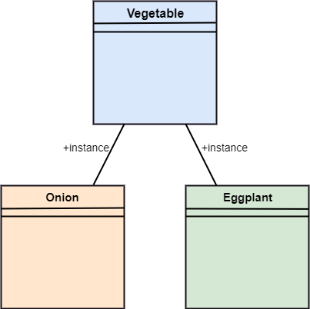

Directed Association
The directed association is concerned with the direction of flow inside association classes. The flow of association can be shown by employing a directed association. The directed association between two classes is represented by a line with an arrowhead, which indicates the navigation direction. The flow of association from one class to another is always in one direction.
It can be said that there is an association between a person and the company. The person works for the company. Here the person works for the company, and not the company works for a person.
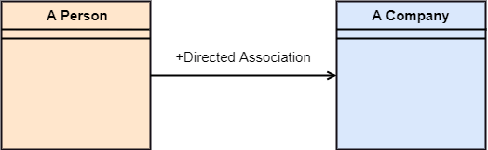

UML-Dependency
Dependency depicts how various things within a system are dependent on each other. In UML, a dependency relationship is the kind of relationship in which a client (one element) is dependent on the supplier (another element). It is used in class diagrams, component diagrams, deployment diagrams, and use-case diagrams, which indicates that a change to the supplier necessitates a change to the client. An example is given below:
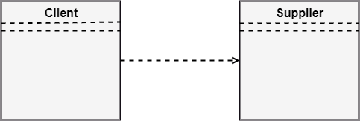

Types of Dependency Relationship
Following are the type of dependency relationships, keywords, or stereotypes given below:
- <<derive>> -It is a constraint that specifies the template can be initialized by the source at the target location utilizing given parameters.
- <<derive>> -It represents that the source object's location can be evaluated from the target object.
- <<friend>> -It states the uniqueness of the source in the target object.
- <<instanceOf>> -It states that an instance of a target classifier is the source object.
- <<instantiate>> -It defines the capability of the source object, creating instances of a target object.
- <<refine>> -It states that the source object comprises of exceptional abstraction than that of the target object.
- <<use>> -When the packages are created in UML, the use of stereotype is used as it describes that the elements of the source package can also exist in the target package. It specifies that the source package uses some of the elements of the target package.
- <<substitute>> -The substitute stereotype state that the client can be substituted at the runtime for the supplier.
- <<access>> -It is also called as private merging in which the source package accesses the element of the target package.
- <<import>> -It specifies that target imports the source package's element as they are defined within the target. It is also known as public merging.
- <<permit>> -It describes that the source element can access the supplier element or whatever visibility is provided by the supplier.
- <<extend>> -It states that the behavior of the source element can be extended by the target.
- <<include>> -It describes the source element, which can include the behavior of another element at a specific location, just like a function call in C/C++.
- <<become>> -It states that target is similar to the source with distinct roles and values.
- <<call>> -It specifies that the target object can be invoked by the source.
- <<copy>> -It states that the target is an independent replica of a source object.
- <<parameter>> -It describes that the supplier is a parameter of the client's actions.
- <<send>> -The client act as an operation, which sends some unspecified targets to the supplier.
- UML-Generalization
- In UML modeling, a generalization relationship is a relationship that implements the concept of object orientation called inheritance. The generalization relationship occurs between two entities or objects, such that one entity is the parent, and the other one is the child. The child inherits the functionality of its parent and can access as well as update it.
- Generalization relationship is utilized in class, component, deployment, and use case diagrams to specify that the child inherits actions, characteristics, and relationships from its parent.
- To meet UML's standard, it necessitates usage of the same types of model elements in the generalization relationship, i.e., generalization relation can either be used between actors or between use cases, but not between an actor and a use case.
- The generalization relationship is incorporated to record attributes, operations, and relationships in a parent model element so that it can be inherited in one or more child model elements.
- The parent model element can have as many children, and also, the child can have one or more parents. But most commonly, it can be seen that there is one parent model element and multiple child model elements. The generalization relationship does not consist of names. The generalization relationship is represented by a solid line with a hollow arrowhead pointing towards the parent model element from the child model element.
- 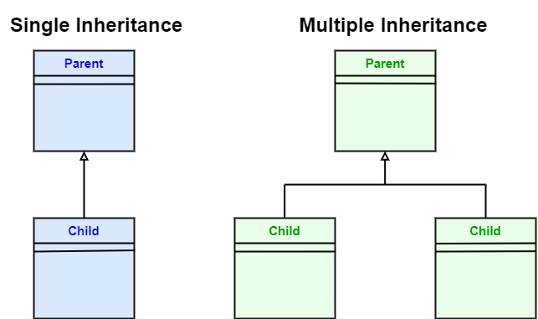
- Stereotypes and their constraints
- <<implementation>> - It is used to show that the child is implemented by its parent, such that the child object inherits the structure and behavior of its parent object without disobeying the rules. The implementation of stereotype is mostly used in single inheritance.
- In the generalization stereotype, there are two types of constraints that are complete and incomplete to check if all the child objects are involved or not in the relationship.
- Example:
- As we know, the bank account can be of two types; Savings Account and Credit Card Account. Both the savings and the credit card account inherits the generalized properties from the Bank Account, which is Account Number, Account Balance, etc.

- 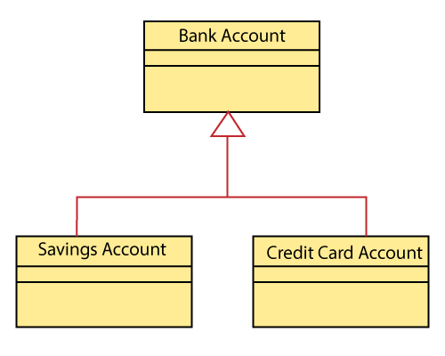

UML-Realization
In UML modeling, the realization is a relationship between two objects, where the client (one model element) implements the responsibility specified by the supplier (another model element). The realization relationship can be employed in class diagrams and components diagrams.
The realization relationship does not have names. It is mostly found in the interfaces. It is represented by a dashed line with a hollow arrowhead at one end that points from the client to the server.

Interface Realization
Interface realization is a kind of specialized relation between the classifier and the interface. In interface realization relationship, realizing classifiers conforms to the contract defined by the interface.
A classifier implementing an interface identifies the objects that conform to the interface and any of its ancestors. A classifier can execute one or more interfaces. The set of interfaces that are implemented by the classifier are its given interfaces. The given interfaces are the set of services offered by the classifiers to its clients.
The interface realization relationship does not contain names, and if you name it, then the name will appear beside the connector in the diagram.
The interface realization relationship is represented by a dashed line with a hollow arrowhead, which points from the classifier to the given interface.
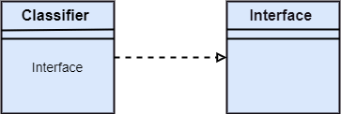

Types of realization:
1. Canonical form: In UML, the canonical form realizes the interfaces across the system. An interface stereotype is used for creating an interface, and a realization relationship is employed to realize (implement) a specific interface. In this, the realization relationship is represented by a dashed line with a hollow arrowhead, and the interface is implemented using an object.
From the diagram given below, it can be seen that the object Account Business Rules realizes the interface Iruleagent.
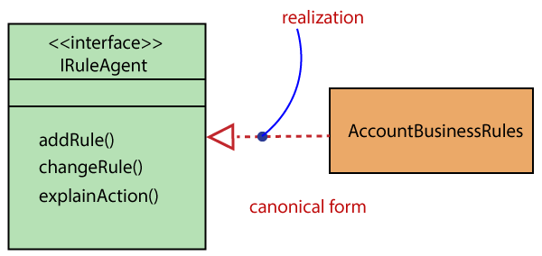
2. Elided form: It is that kind of realization relationship in which the interface is represented by a circle, also known as a lollipop notation. When an interface is realized employing anything present in the system, then an elided structure is created.
Here the interface Iruleagent is denoted by an elided form, which is realized by acctrule.dll.
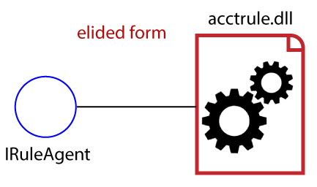

UML Class Diagram
The class diagram depicts a static view of an application. It represents the types of objects residing in the system and the relationships between them. A class consists of its objects, and also it may inherit from other classes. A class diagram is used to visualize, describe, document various different aspects of the system, and also construct executable software code.
It shows the attributes, classes, functions, and relationships to give an overview of the software system. It constitutes class names, attributes, and functions in a separate compartment that helps in software development. Since it is a collection of classes, interfaces, associations, collaborations, and constraints, it is termed as a structural diagram.

Purpose of Class Diagrams
The main purpose of class diagrams is to build a static view of an application. It is the only diagram that is widely used for construction, and it can be mapped with object-oriented languages. It is one of the most popular UML diagrams. Following are the purpose of class diagrams given below:
- It analyses and designs a static view of an application.
- It describes the major responsibilities of a system.
- It is a base for component and deployment diagrams.
- It incorporates forward and reverse engineering.

Benefits of Class Diagrams
- It can represent the object model for complex systems.
- It reduces the maintenance time by providing an overview of how an application is structured before coding.
- It provides a general schematic of an application for better understanding.
- It represents a detailed chart by highlighting the desired code, which is to be programmed.
- It is helpful for the stakeholders and the developers.

Vital components of a Class Diagram
The class diagram is made up of three sections:
- Upper Section: The upper section encompasses the name of the class. A class is a representation of similar objects that shares the same relationships, attributes, operations, and semantics. Some of the following rules that should be taken into account while representing a class are given below:
  - Capitalize the initial letter of the class name.
  - Place the class name in the center of the upper section.
  - A class name must be written in bold format.
  - The name of the abstract class should be written in italics format.
- Middle Section: The middle section constitutes the attributes, which describe the quality of the class. The attributes have the following characteristics:
  - The attributes are written along with its visibility factors, which are public (+), private (-), protected (#), and package (~).
  - The accessibility of an attribute class is illustrated by the visibility factors.
  - A meaningful name should be assigned to the attribute, which will explain its usage inside the class.
- Lower Section: The lower section contain methods or operations. The methods are represented in the form of a list, where each method is written in a single line. It demonstrates how a class interacts with data.
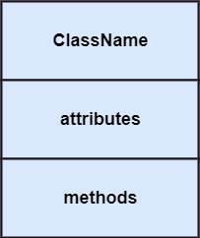

Relationships
In UML, relationships are of three types:
- Dependency: A dependency is a semantic relationship between two or more classes where a change in one class cause changes in another class. It forms a weaker relationship.
In the following example, Student_Name is dependent on the Student_Id.
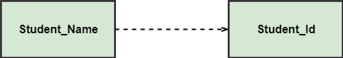
- Generalization: A generalization is a relationship between a parent class (superclass) and a child class (subclass). In this, the child class is inherited from the parent class.
For example, The Current Account, Saving Account, and Credit Account are the generalized form of Bank Account.
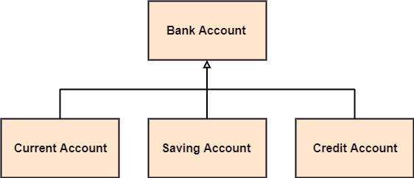
- Association: It describes a static or physical connection between two or more objects. It depicts how many objects are there in the relationship.
For example, a department is associated with the college.
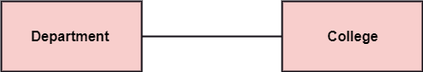
Multiplicity: It defines a specific range of allowable instances of attributes. In case if a range is not specified, one is considered as a default multiplicity.
For example, multiple patients are admitted to one hospital.
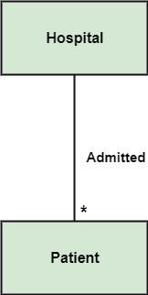
Aggregation: An aggregation is a subset of association, which represents has a relationship. It is more specific then association. It defines a part-whole or part-of relationship. In this kind of relationship, the child class can exist independently of its parent class.
The company encompasses a number of employees, and even if one employee resigns, the company still exists.
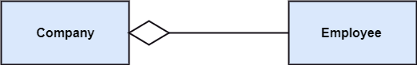
Composition: The composition is a subset of aggregation. It portrays the dependency between the parent and its child, which means if one part is deleted, then the other part also gets discarded. It represents a whole-part relationship.
A contact book consists of multiple contacts, and if you delete the contact book, all the contacts will be lost.
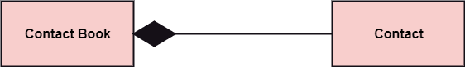

Abstract Classes
In the abstract class, no objects can be a direct entity of the abstract class. The abstract class can neither be declared nor be instantiated. It is used to find the functionalities across the classes. The notation of the abstract class is similar to that of class; the only difference is that the name of the class is written in italics. Since it does not involve any implementation for a given function, it is best to use the abstract class with multiple objects.
Let us assume that we have an abstract class named displacement with a method declared inside it, and that method will be called as a drive (). Now, this abstract class method can be implemented by any object, for example, car, bike, scooter, cycle, etc.
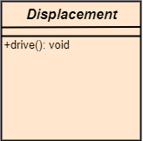

How to draw a Class Diagram?
The class diagram is used most widely to construct software applications. It not only represents a static view of the system but also all the major aspects of an application. A collection of class diagrams as a whole represents a system.
Some key points that are needed to keep in mind while drawing a class diagram are given below:
- To describe a complete aspect of the system, it is suggested to give a meaningful name to the class diagram.
- The objects and their relationships should be acknowledged in advance.
- The attributes and methods (responsibilities) of each class must be known.
- A minimum number of desired properties should be specified as more number of the unwanted property will lead to a complex diagram.
- Notes can be used as and when required by the developer to describe the aspects of a diagram.
- The diagrams should be redrawn and reworked as many times to make it correct before producing its final version.

Class Diagram Example
A class diagram describing the sales order system is given below.
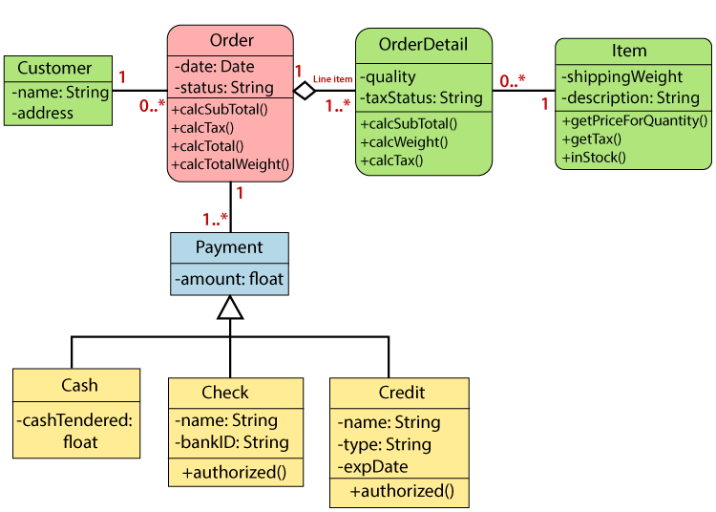

Usage of Class diagrams
The class diagram is used to represent a static view of the system. It plays an essential role in the establishment of the component and deployment diagrams. It helps to construct an executable code to perform forward and backward engineering for any system, or we can say it is mainly used for construction. It represents the mapping with object-oriented languages that are C++, Java, etc. Class diagrams can be used for the following purposes:
- To describe the static view of a system.
- To show the collaboration among every instance in the static view.
- To describe the functionalities performed by the system.
- To construct the software application using object-oriented languages.

UML Object Diagram
Object diagrams are dependent on the class diagram as they are derived from the class diagram. It represents an instance of a class diagram. The objects help in portraying a static view of an object-oriented system at a specific instant.
Both the object and class diagram are similar to some extent; the only difference is that the class diagram provides an abstract view of a system. It helps in visualizing a particular functionality of a system.

Notation of an Object Diagram
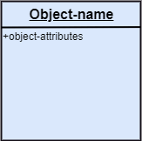

Purpose of Object Diagram
The object diagram holds the same purpose as that of a class diagram. The class diagram provides an abstract view which comprises of classes and their relationships, whereas the object diagram represents an instance at a particular point of time.
The object diagram is actually similar to the concrete (actual) system behavior. The main purpose is to depict a static view of a system.
Following are the purposes enlisted below:
- It is used to perform forward and reverse engineering.
- It is used to understand object behavior and their relationships practically.
- It is used to get a static view of a system.
- It is used to represent an instance of a system.

Example of Object Diagram
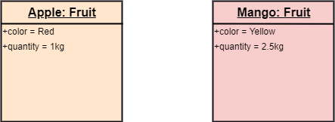

How to draw an Object Diagram?
- All the objects present in the system should be examined before start drawing the object diagram.
- Before creating the object diagram, the relation between the objects must be acknowledged.
- The association relationship among the entities must be cleared already.
- To represent the functionality of an object, a proper meaningful name should be assigned.
- The objects are to be examined to understand its functionality.

Applications of Object diagrams
The following are the application areas where the object diagrams can be used.
- To build a prototype of a system.
- To model complex data structures.
- To perceive the system from a practical perspective.
- Reverse engineering.

Class vs. Object diagram
Serial No. | Class Diagram | Object Diagram
1. | It depicts the static view of a system. | It portrays the real-time behavior of a system.
2. | Dynamic changes are not included in the class diagram. | Dynamic changes are captured in the object diagram.
3. | The data values and attributes of an instance are not involved here. | It incorporates data values and attributes of an entity.
4. | The object behavior is manipulated in the class diagram. | Objects are the instances of a class.

UML Component Diagram
A component diagram is used to break down a large object-oriented system into the smaller components, so as to make them more manageable. It models the physical view of a system such as executables, files, libraries, etc. that resides within the node.
It visualizes the relationships as well as the organization between the components present in the system. It helps in forming an executable system. A component is a single unit of the system, which is replaceable and executable. The implementation details of a component are hidden, and it necessitates an interface to execute a function. It is like a black box whose behavior is explained by the provided and required interfaces.

Notation of a Component Diagram
a) A component
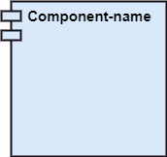
b) A node
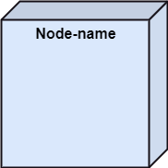

Purpose of a Component Diagram
Since it is a special kind of a UML diagram, it holds distinct purposes. It describes all the individual components that are used to make the functionalities, but not the functionalities of the system. It visualizes the physical components inside the system. The components can be a library, packages, files, etc.
The component diagram also describes the static view of a system, which includes the organization of components at a particular instant. The collection of component diagrams represents a whole system.
The main purpose of the component diagram are enlisted below:
- It envisions each component of a system.
- It constructs the executable by incorporating forward and reverse engineering.
- It depicts the relationships and organization of components.

Why use Component Diagram?
The component diagrams have remarkable importance. It is used to depict the functionality and behavior of all the components present in the system, unlike other diagrams that are used to represent the architecture of the system, working of a system, or simply the system itself.
In UML, the component diagram portrays the behavior and organization of components at any instant of time. The system cannot be visualized by any individual component, but it can be by the collection of components.
Following are some reasons for the requirement of the component diagram:
- It portrays the components of a system at the runtime.
- It is helpful in testing a system.
- It envisions the links between several connections.

When to use a Component Diagram?
It represents various physical components of a system at runtime. It is helpful in visualizing the structure and the organization of a system. It describes how individual components can together form a single system. Following are some reasons, which tells when to use component diagram:
- To divide a single system into multiple components according to the functionality.
- To represent the component organization of the system.

How to Draw a Component Diagram?
The component diagram is helpful in representing the physical aspects of a system, which are files, executables, libraries, etc. The main purpose of a component diagram is different from that of other diagrams. It is utilized in the implementation phase of any application.
Once the system is designed employing different UML diagrams, and the artifacts are prepared, the component diagram is used to get an idea of implementation. It plays an essential role in implementing applications efficiently.
Following are some artifacts that are needed to be identified before drawing a component diagram:
- What files are used inside the system?
- What is the application of relevant libraries and artifacts?
- What is the relationship between the artifacts?
Following are some points that are needed to be kept in mind after the artifacts are identified:
- Using a meaningful name to ascertain the component for which the diagram is about to be drawn.
- Before producing the required tools, a mental layout is to be made.
- To clarify the important points, notes can be incorporated.

Example of a Component Diagram
A component diagram for an online shopping system is given below:
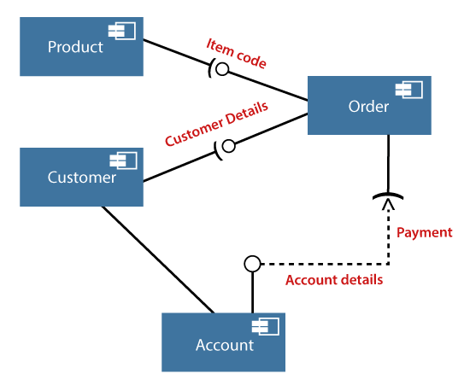

Where to use Component Diagrams?
The component diagram is a special purpose diagram, which is used to visualize the static implementation view of a system. It represents the physical components of a system, or we can say it portrays the organization of the components inside a system. The components, such as libraries, files, executables, etc. are first needed to be organized before the implementation.
The component diagram can be used for the followings:
- To model the components of the system.
- To model the schemas of a database.
- To model the applications of an application.
- To model the system's source code.

UML Deployment Diagram
The deployment diagram visualizes the physical hardware on which the software will be deployed. It portrays the static deployment view of a system. It involves the nodes and their relationships.
It ascertains how software is deployed on the hardware. It maps the software architecture created in design to the physical system architecture, where the software will be executed as a node. Since it involves many nodes, the relationship is shown by utilizing communication paths.

Purpose of Deployment Diagram
The main purpose of the deployment diagram is to represent how software is installed on the hardware component. It depicts in what manner a software interacts with hardware to perform its execution.
Both the deployment diagram and the component diagram are closely interrelated to each other as they focus on software and hardware components. The component diagram represents the components of a system, whereas the deployment diagram describes how they are actually deployed on the hardware.
The deployment diagram does not focus on the logical components of the system, but it put its attention on the hardware topology.
Following are the purposes of deployment diagram enlisted below:
- To envision the hardware topology of the system.
- To represent the hardware components on which the software components are installed.
- To describe the processing of nodes at the runtime.

Symbol and notation of Deployment diagram
The deployment diagram consist of the following notations:
- A component
- An artifact
- An interface
- A node
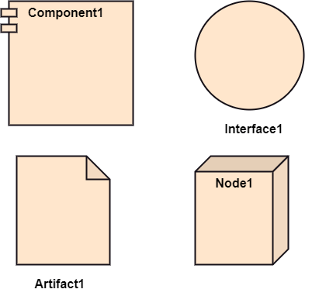

How to draw a Deployment Diagram?
The deployment diagram portrays the deployment view of the system. It helps in visualizing the topological view of a system. It incorporates nodes, which are physical hardware. The nodes are used to execute the artifacts. The instances of artifacts can be deployed on the instances of nodes.
Since it plays a critical role during the administrative process, it involves the following parameters:
- High performance
- Scalability
- Maintainability
- Portability
- Easily understandable
One of the essential elements of the deployment diagram is the nodes and artifacts. So it is necessary to identify all of the nodes and the relationship between them. It becomes easier to develop a deployment diagram if all of the nodes, artifacts, and their relationship is already known.

Example of a Deployment diagram
A deployment diagram for the Apple iTunes application is given below.
The iTunes setup can be downloaded from the iTunes website, and also it can be installed on the home computer. Once the installation and the registration are done, iTunes application can easily interconnect with the Apple iTunes store. Users can purchase and download music, video, TV serials, etc. and cache it in the media library.
Devices like Apple iPod Touch and Apple iPhone can update its own media library from the computer with iTunes with the help of USB or simply by downloading media directly from the Apple iTunes store using wireless protocols, for example; Wi-Fi, 3G, or EDGE.
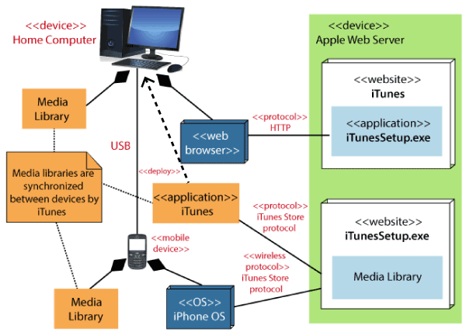

When to use a Deployment Diagram?
The deployment diagram is mostly employed by network engineers, system administrators, etc. with the purpose of representing the deployment of software on the hardware system. It envisions the interaction of the software with the hardware to accomplish the execution. The selected hardware must be of good quality so that the software can work more efficiently at a faster rate by producing accurate results in no time.
The software applications are quite complex these days, as they are standalone, distributed, web-based, etc. So, it is very necessary to design efficient software.
Deployment diagrams can be used for the followings:
- To model the network and hardware topology of a system.
- To model the distributed networks and systems.
- Implement forwarding and reverse engineering processes.
- To model the hardware details for a client/server system.
- For modeling the embedded system.

UML Interaction Diagram
As the name suggests, the interaction diagram portrays the interactions between distinct entities present in the model. It amalgamates both the activity and sequence diagrams. The communication is nothing but units of the behavior of a classifier that provides context for interactions.
A set of messages that are interchanged between the entities to achieve certain specified tasks in the system is termed as interaction. It may incorporate any feature of the classifier of which it has access. In the interaction diagram, the critical component is the messages and the lifeline.
In UML, the interaction overview diagram initiates the interaction between the objects utilizing message passing. While drawing an interaction diagram, the entire focus is to represent the relationship among different objects which are available within the system boundary and the message exchanged by them to communicate with each other.
The message exchanged among objects is either to pass some information or to request some information. And based on the information, the interaction diagram is categorized into the sequence diagram, collaboration diagram, and timing diagram.
The sequence diagram envisions the order of the flow of messages inside the system by depicting the communication between two lifelines, just like a time-ordered sequence of events.
The collaboration diagram, which is also known as the communication diagram, represents how lifelines connect within the system, whereas the timing diagram focuses on that instant when a message is passed from one element to the other.

Notation of an Interaction Diagram
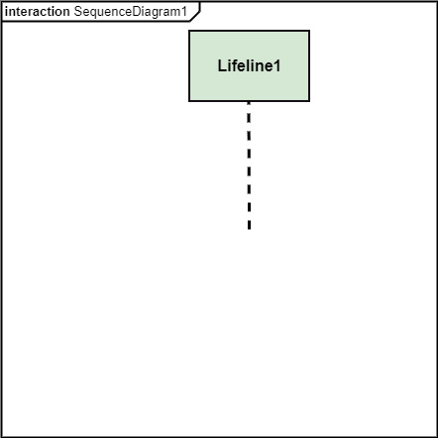

Purpose of an Interaction Diagram
The interaction diagram helps to envision the interactive (dynamic) behavior of any system. It portrays how objects residing in the system communicates and connects to each other. It also provides us with a context of communication between the lifelines inside the system.
Following are the purpose of an interaction diagram given below:
- To visualize the dynamic behavior of the system.
- To envision the interaction and the message flow in the system.
- To portray the structural aspects of the entities within the system.
- To represent the order of the sequenced interaction in the system.
- To visualize the real-time data and represent the architecture of an object-oriented system.

How to draw an Interaction Diagram?
Since the main purpose of an interaction diagram is to visualize the dynamic behavior of the system, it is important to understand what a dynamic aspect really is and how we can visualize it. The dynamic aspect is nothing but a screenshot of the system at the run time.
Before drawing an interaction diagram, the first step is to discover the scenario for which the diagram will be made. Next, we will identify various lifelines that will be invoked in the communication, and then we will classify each lifeline. After that, the connections are investigated and how the lifelines are interrelated to each other.
Following are some things that are needed:
- A total no of lifeline which will take part in the communication.
- The sequence of the message flow among several entities within the system.
- No operators used to ease out the functionality of the diagram.
- Several distinct messages that depict the interactions in a precise and clear way.
- The organization and structure of a system.
- The order of the sequence of the flow of messages.
- Total no of time constructs of an object.

Use of an Interaction Diagram
The interaction diagram can be used for:
- The sequence diagram is employed to investigate a new application.
- The interaction diagram explores and compares the use of the collaboration diagram sequence diagram and the timing diagram.
- The interaction diagram represents the interactive (dynamic) behavior of the system.
- The sequence diagram portrays the order of control flow from one element to the other elements inside the system, whereas the collaboration diagrams are employed to get an overview of the object architecture of the system.
- The interaction diagram models the system as a time-ordered sequence of a system.
- The interaction diagram models the system as a time-ordered sequence of a system.
- The interaction diagram systemizes the structure of the interactive elements.

UML Use Case Diagram
A use case diagram is used to represent the dynamic behavior of a system. It encapsulates the system's functionality by incorporating use cases, actors, and their relationships. It models the tasks, services, and functions required by a system/subsystem of an application. It depicts the high-level functionality of a system and also tells how the user handles a system.

Purpose of Use Case Diagrams
The main purpose of a use case diagram is to portray the dynamic aspect of a system. It accumulates the system's requirement, which includes both internal as well as external influences. It invokes persons, use cases, and several things that invoke the actors and elements accountable for the implementation of use case diagrams. It represents how an entity from the external environment can interact with a part of the system.
Following are the purposes of a use case diagram given below:
- It gathers the system's needs.
- It depicts the external view of the system.
- It recognizes the internal as well as external factors that influence the system.
- It represents the interaction between the actors.

How to draw a Use Case diagram?
It is essential to analyze the whole system before starting with drawing a use case diagram, and then the system's functionalities are found. And once every single functionality is identified, they are then transformed into the use cases to be used in the use case diagram.
After that, we will enlist the actors that will interact with the system. The actors are the person or a thing that invokes the functionality of a system. It may be a system or a private entity, such that it requires an entity to be pertinent to the functionalities of the system to which it is going to interact.
Once both the actors and use cases are enlisted, the relation between the actor and use case/ system is inspected. It identifies the no of times an actor communicates with the system. Basically, an actor can interact multiple times with a use case or system at a particular instance of time.
Following are some rules that must be followed while drawing a use case diagram:
- A pertinent and meaningful name should be assigned to the actor or a use case of a system.
- The communication of an actor with a use case must be defined in an understandable way.
- Specified notations to be used as and when required.
- The most significant interactions should be represented among the multiple no of interactions between the use case and actors.

Example of a Use Case Diagram
A use case diagram depicting the Online Shopping website is given below.
Here the Web Customer actor makes use of any online shopping website to purchase online. The top-level uses are as follows; View Items, Make Purchase, Checkout, Client Register. The View Items use case is utilized by the customer who searches and view products. The Client Register use case allows the customer to register itself with the website for availing gift vouchers, coupons, or getting a private sale invitation. It is to be noted that the Checkout is an included use case, which is part of Making Purchase, and it is not available by itself.
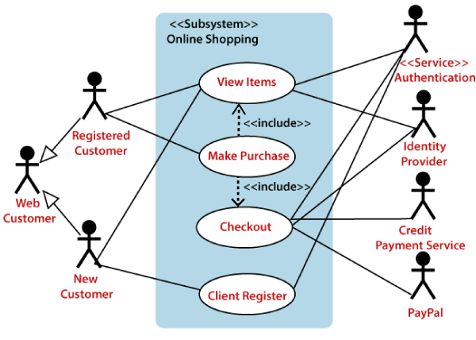
The View Items is further extended by several use cases such as; Search Items, Browse Items, View Recommended Items, Add to Shopping Cart, Add to Wish list. All of these extended use cases provide some functions to customers, which allows them to search for an item. The View Items is further extended by several use cases such as; Search Items, Browse Items, View Recommended Items, Add to Shopping Cart, Add to Wish list. All of these extended use cases provide some functions to customers, which allows them to search for an item.
Both View Recommended Item and Add to Wish List include the Customer Authentication use case, as they necessitate authenticated customers, and simultaneously item can be added to the shopping cart without any user authentication.
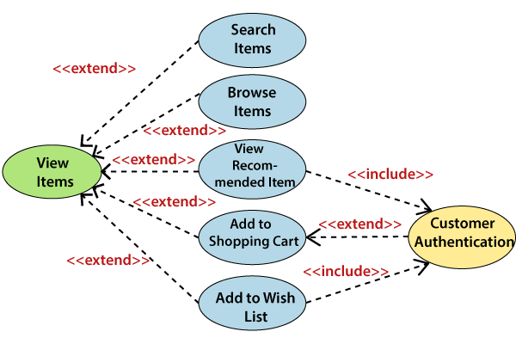
Similarly, the Checkout use case also includes the following use cases, as shown below. It requires an authenticated Web Customer, which can be done by login page, user authentication cookie ("Remember me"), or Single Sign-On (SSO). SSO needs an external identity provider's participation, while Web site authentication service is utilized in all these use cases.
The Checkout use case involves Payment use case that can be done either by the credit card and external credit payment services or with PayPal.
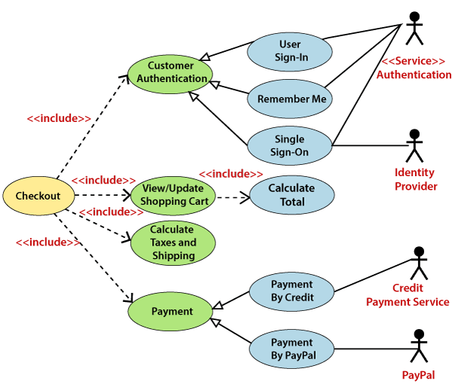

Important tips for drawing a Use Case diagram
Following are some important tips that are to be kept in mind while drawing a use case diagram:
- A simple and complete use case diagram should be articulated.
- A use case diagram should represent the most significant interaction among the multiple interactions.
- At least one module of a system should be represented by the use case diagram.
- If the use case diagram is large and more complex, then it should be drawn more generalized

Sequence Diagram
The sequence diagram represents the flow of messages in the system and is also termed as an event diagram. It helps in envisioning several dynamic scenarios. It portrays the communication between any two lifelines as a time-ordered sequence of events, such that these lifelines took part at the run time. In UML, the lifeline is represented by a vertical bar, whereas the message flow is represented by a vertical dotted line that extends across the bottom of the page. It incorporates the iterations as well as branching.

Purpose of a Sequence Diagram
- To model high-level interaction among active objects within a system.
- To model interaction among objects inside a collaboration realizing a use case.
- It either models generic interactions or some certain instances of interaction.

Notations of a Sequence Diagram

Lifeline
An individual participant in the sequence diagram is represented by a lifeline. It is positioned at the top of the diagram.
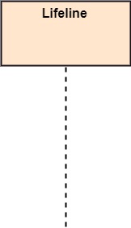

Actor
A role played by an entity that interacts with the subject is called as an actor. It is out of the scope of the system. It represents the role, which involves human users and external hardware or subjects. An actor may or may not represent a physical entity, but it purely depicts the role of an entity. Several distinct roles can be played by an actor or vice versa.


Activation
It is represented by a thin rectangle on the lifeline. It describes that time period in which an operation is performed by an element, such that the top and the bottom of the rectangle is associated with the initiation and the completion time, each respectively.
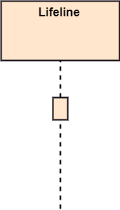

Messages
The messages depict the interaction between the objects and are represented by arrows. They are in the sequential order on the lifeline. The core of the sequence diagram is formed by messages and lifelines.
Following are types of messages enlisted below:
- Call Message: It defines a particular communication between the lifelines of an interaction, which represents that the target lifeline has invoked an operation.
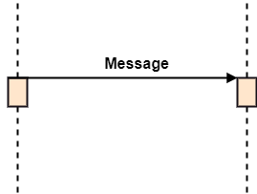
- Return Message: It defines a particular communication between the lifelines of interaction that represent the flow of information from the receiver of the corresponding caller message.
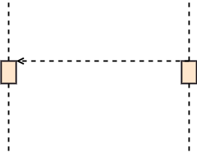
- Self Message: It describes a communication, particularly between the lifelines of an interaction that represents a message of the same lifeline, has been invoked.
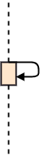
- Recursive Message: A self message sent for recursive purpose is called a recursive message. In other words, it can be said that the recursive message is a special case of the self message as it represents the recursive calls.
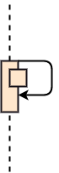
- Create Message: It describes a communication, particularly between the lifelines of an interaction describing that the target (lifeline) has been instantiated.
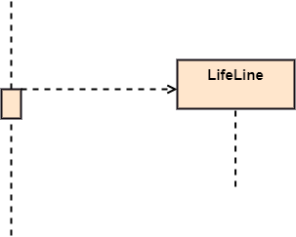
- Destroy Message: It describes a communication, particularly between the lifelines of an interaction that depicts a request to destroy the lifecycle of the target.
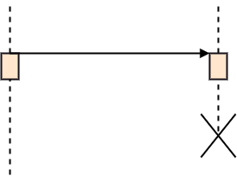
- Duration Message: It describes a communication particularly between the lifelines of an interaction, which portrays the time passage of the message while modeling a system.
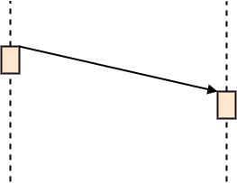

Note
A note is the capability of attaching several remarks to the element. It basically carries useful information for the modelers.
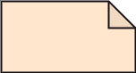

Sequence Fragments
- Sequence fragments have been introduced by UML 2.0, which makes it quite easy for the creation and maintenance of an accurate sequence diagram.
- It is represented by a box called a combined fragment, encloses a part of interaction inside a sequence diagram.
- The type of fragment is shown by a fragment operator.
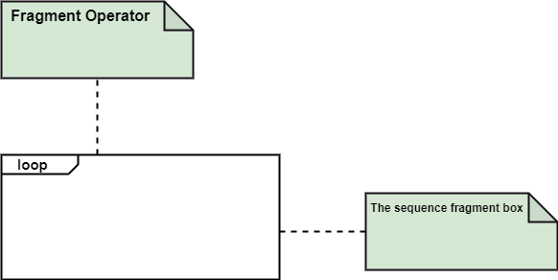

Types of fragments
Following are the types of fragments enlisted below;
Operator | Fragment Type
alt | Alternative multiple fragments: The only fragment for which the condition is true, will execute.
opt | Optional: If the supplied condition is true, only then the fragments will execute. It is similar to alt with only one trace.
par | Parallel: Parallel executes fragments.
loop | Loop: Fragments are run multiple times, and the basis of interaction is shown by the guard.
region | Critical region: Only one thread can execute a fragment at once.
neg | Negative: A worthless communication is shown by the fragment.
ref | Reference: An interaction portrayed in another diagram. In this, a frame is drawn so as to cover the lifelines involved in the communication. The parameter and return value can be explained.
sd | Sequence Diagram: It is used to surround the whole sequence diagram.

Example of a Sequence Diagram
An example of a high-level sequence diagram for online bookshop is given below.
Any online customer can search for a book catalog, view a description of a particular book, add a book to its shopping cart, and do checkout.
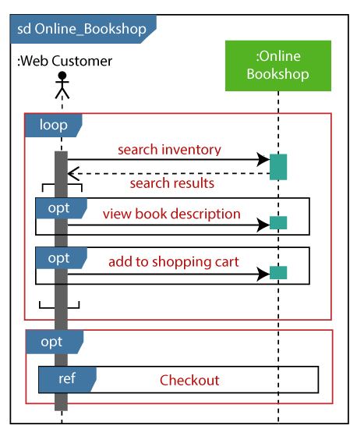

Benefits of a Sequence Diagram
- It explores the real-time application.
- It depicts the message flow between the different objects.
- It has easy maintenance.
- It is easy to generate.
- Implement both forward and reverse engineering.
- It can easily update as per the new change in the system.

The drawback of a Sequence Diagram
- In the case of too many lifelines, the sequence diagram can get more complex.
- The incorrect result may be produced, if the order of the flow of messages changes.
- Since each sequence needs distinct notations for its representation, it may make the diagram more complex.
- The type of sequence is decided by the type of message.

UML Collaboration Diagram
The collaboration diagram is used to show the relationship between the objects in a system. Both the sequence and the collaboration diagrams represent the same information but differently. Instead of showing the flow of messages, it depicts the architecture of the object residing in the system as it is based on object-oriented programming. An object consists of several features. Multiple objects present in the system are connected to each other. The collaboration diagram, which is also known as a communication diagram, is used to portray the object's architecture in the system.

Notations of a Collaboration Diagram
Following are the components of a component diagram that are enlisted below:
- Objects: The representation of an object is done by an object symbol with its name and class underlined, separated by a colon.
In the collaboration diagram, objects are utilized in the following ways:
  - The object is represented by specifying their name and class.
  - It is not mandatory for every class to appear.
  - A class may constitute more than one object.
  - In the collaboration diagram, firstly, the object is created, and then its class is specified.
  - To differentiate one object from another object, it is necessary to name them.
- Actors: In the collaboration diagram, the actor plays the main role as it invokes the interaction. Each actor has its respective role and name. In this, one actor initiates the use case.
- Links: The link is an instance of association, which associates the objects and actors. It portrays a relationship between the objects through which the messages are sent. It is represented by a solid line. The link helps an object to connect with or navigate to another object, such that the message flows are attached to links.
- Messages: It is a communication between objects which carries information and includes a sequence number, so that the activity may take place. It is represented by a labeled arrow, which is placed near a link. The messages are sent from the sender to the receiver, and the direction must be navigable in that particular direction. The receiver must understand the message.
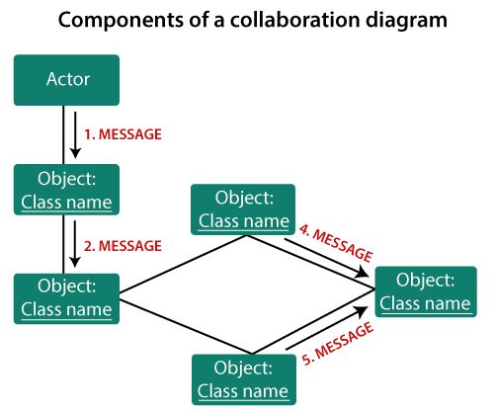

When to use a Collaboration Diagram?
The collaborations are used when it is essential to depict the relationship between the object. Both the sequence and collaboration diagrams represent the same information, but the way of portraying it quite different. The collaboration diagrams are best suited for analyzing use cases.
Following are some of the use cases enlisted below for which the collaboration diagram is implemented:
- To model collaboration among the objects or roles that carry the functionalities of use cases and operations.
- To model the mechanism inside the architectural design of the system.
- To capture the interactions that represent the flow of messages between the objects and the roles inside the collaboration.
- To model different scenarios within the use case or operation, involving a collaboration of several objects and interactions.
- To support the identification of objects participating in the use case.
- In the collaboration diagram, each message constitutes a sequence number, such that the top-level message is marked as one and so on. The messages sent during the same call are denoted with the same decimal prefix, but with different suffixes of 1, 2, etc. as per their occurrence.

Steps for creating a Collaboration Diagram
- Determine the behavior for which the realization and implementation are specified.
- Discover the structural elements that are class roles, objects, and subsystems for performing the functionality of collaboration.
  - Choose the context of an interaction: system, subsystem, use case, and operation.
- Think through alternative situations that may be involved.
  - Implementation of a collaboration diagram at an instance level, if needed.
  - A specification level diagram may be made in the instance level sequence diagram for summarizing alternative situations.

Example of a Collaboration Diagram
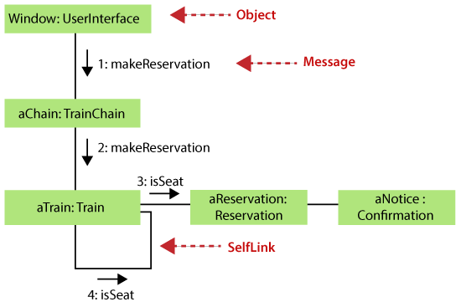

Benefits of a Collaboration Diagram
- The collaboration diagram is also known as Communication Diagram.
- It mainly puts emphasis on the structural aspect of an interaction diagram, i.e., how lifelines are connected.
- The syntax of a collaboration diagram is similar to the sequence diagram; just the difference is that the lifeline does not consist of tails.
- The messages transmitted over sequencing is represented by numbering each individual message.
- The collaboration diagram is semantically weak in comparison to the sequence diagram.
- The special case of a collaboration diagram is the object diagram.
- It focuses on the elements and not the message flow, like sequence diagrams.
- Since the collaboration diagrams are not that expensive, the sequence diagram can be directly converted to the collaboration diagram.
- There may be a chance of losing some amount of information while implementing a collaboration diagram with respect to the sequence diagram.

The drawback of a Collaboration Diagram
- Multiple objects residing in the system can make a complex collaboration diagram, as it becomes quite hard to explore the objects.
- It is a time-consuming diagram.
- After the program terminates, the object is destroyed.
- As the object state changes momentarily, it becomes difficult to keep an eye on every single that has occurred inside the object of a system.

UML State Machine Diagram
The state machine diagram is also called the Statechart or State Transition diagram, which shows the order of states underwent by an object within the system. It captures the software system's behavior. It models the behavior of a class, a subsystem, a package, and a complete system.
It tends out to be an efficient way of modeling the interactions and collaborations in the external entities and the system. It models event-based systems to handle the state of an object. It also defines several distinct states of a component within the system. Each object/component has a specific state.
Following are the types of a state machine diagram that are given below:
- Behavioral state machine
The behavioral state machine diagram records the behavior of an object within the system. It depicts an implementation of a particular entity. It models the behavior of the system.
- Protocol state machine
It captures the behavior of the protocol. The protocol state machine depicts the change in the state of the protocol and parallel changes within the system. But it does not portray the implementation of a particular component.

Why State Machine Diagram?
Since it records the dynamic view of a system, it portrays the behavior of a software application. During a lifespan, an object underwent several states, such that the lifespan exist until the program is executing. Each state depicts some useful information about the object.
It blueprints an interactive system that response back to either the internal events or the external ones. The execution flow from one state to another is represented by a state machine diagram. It visualizes an object state from its creation to its termination.
The main purpose is to depict each state of an individual object. It represents an interactive system and the entities inside the system. It records the dynamic behavior of the system.

Notation of a State Machine Diagram
Following are the notations of a state machine diagram enlisted below:
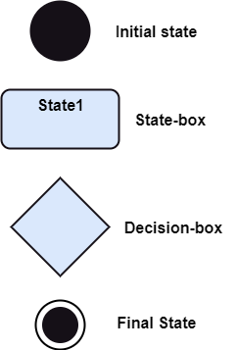
- Initial state: It defines the initial state (beginning) of a system, and it is represented by a black filled circle.
- Final state: It represents the final state (end) of a system. It is denoted by a filled circle present within a circle.
- Decision box: It is of diamond shape that represents the decisions to be made on the basis of an evaluated guard.
- Transition: A change of control from one state to another due to the occurrence of some event is termed as a transition. It is represented by an arrow labeled with an event due to which the change has ensued.
- State box: It depicts the conditions or circumstances of a particular object of a class at a specific point of time. A rectangle with round corners is used to represent the state box.

Types of State
The UML consist of three states:
- Simple state: It does not constitute any substructure.
- Composite state: It consists of nested states (substates), such that it does not contain more than one initial state and one final state. It can be nested to any level.
- Submachine state: The submachine state is semantically identical to the composite state, but it can be reused.

How to Draw a State Machine Diagram?
The state machine diagram is used to portray various states underwent by an object. The change in one state to another is due to the occurrence of some event. All of the possible states of a particular component must be identified before drawing a state machine diagram.
The primary focus of the state machine diagram is to depict the states of a system. These states are essential while drawing a state transition diagram. The objects, states, and events due to which the state transition occurs must be acknowledged before the implementation of a state machine diagram.
Following are the steps that are to be incorporated while drawing a state machine diagram:
- A unique and understandable name should be assigned to the state transition that describes the behavior of the system.
- Out of multiple objects, only the essential objects are implemented.
- A proper name should be given to the events and the transitions.

When to use a State Machine Diagram?
The state machine diagram implements the real-world models as well as the object-oriented systems. It records the dynamic behavior of the system, which is used to differentiate between the dynamic and static behavior of a system.
It portrays the changes underwent by an object from the start to the end. It basically envisions how triggering an event can cause a change within the system.
State machine diagram is used for:
- For modeling the object states of a system.
- For modeling the reactive system as it consists of reactive objects.
- For pinpointing the events responsible for state transitions.
- For implementing forward and reverse engineering.

Example of a State Machine Diagram
An example of a top-level state machine diagram showing Bank Automated Teller Machine (ATM) is given below.
Initially, the ATM is turned off. After the power supply is turned on, the ATM starts performing the startup action and enters into the Self Test state. If the test fails, the ATM will enter into the Out Of Service state, or it will undergo a triggerless transition to the Idle state. This is the state where the customer waits for the interaction.
Whenever the customer inserts the bank or credit card in the ATM's card reader, the ATM state changes from Idle to Serving Customer, the entry action readCard is performed after entering into Serving Customer state. Since the customer can cancel the transaction at any instant, so the transition from Serving Customer state back to the Idle state could be triggered by cancel event.
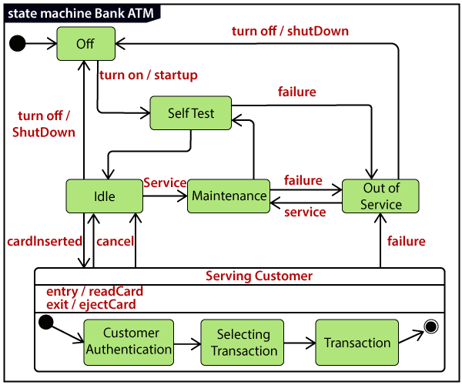
Here the Serving Customer is a composite state with sequential substates that are Customer Authentication, Selecting Transaction, and Transaction.
Customer Authentication and Transaction are the composite states itself is displayed by a hidden decomposition indication icon. After the transaction is finished, the Serving Customer encompasses a triggerless transition back to the Idle state. On leaving the state, it undergoes the exit action ejectCard that discharges the customer card.

State Machine vs. Flowchart
State Machine | Flowchart
It portrays several states of a system. | It demonstrates the execution flow of a program.
It encompasses the concept of WAIT, i.e., wait for an event or an action. | It does not constitute the concept of WAIT.
It is for real-world modeling systems. | It envisions the branching sequence of a system.
It is a modeling diagram. | It is a data flow diagram (DFD)
It is concerned with several states of a system. | It focuses on control flow and path.

UML Activity Diagram
In UML, the activity diagram is used to demonstrate the flow of control within the system rather than the implementation. It models the concurrent and sequential activities.
The activity diagram helps in envisioning the workflow from one activity to another. It put emphasis on the condition of flow and the order in which it occurs. The flow can be sequential, branched, or concurrent, and to deal with such kinds of flows, the activity diagram has come up with a fork, join, etc.
It is also termed as an object-oriented flowchart. It encompasses activities composed of a set of actions or operations that are applied to model the behavioral diagram.

Components of an Activity Diagram
Following are the component of an activity diagram:
Activities
The categorization of behavior into one or more actions is termed as an activity. In other words, it can be said that an activity is a network of nodes that are connected by edges. The edges depict the flow of execution. It may contain action nodes, control nodes, or object nodes.
The control flow of activity is represented by control nodes and object nodes that illustrates the objects used within an activity. The activities are initiated at the initial node and are terminated at the final node.
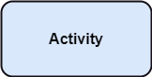
Activity partition /swimlane
The swimlane is used to cluster all the related activities in one column or one row. It can be either vertical or horizontal. It used to add modularity to the activity diagram. It is not necessary to incorporate swimlane in the activity diagram. But it is used to add more transparency to the activity diagram.
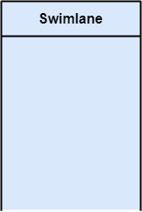
Forks
Forks and join nodes generate the concurrent flow inside the activity. A fork node consists of one inward edge and several outward edges. It is the same as that of various decision parameters. Whenever a data is received at an inward edge, it gets copied and split crossways various outward edges. It split a single inward flow into multiple parallel flows.
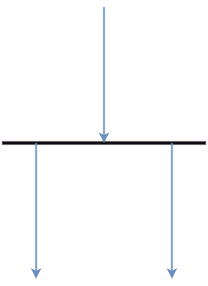
Join Nodes
Join nodes are the opposite of fork nodes. A Logical AND operation is performed on all of the inward edges as it synchronizes the flow of input across one single output (outward) edge.
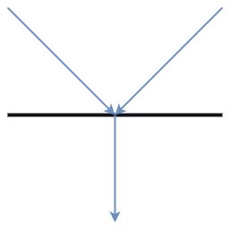
Pins
It is a small rectangle, which is attached to the action rectangle. It clears out all the messy and complicated thing to manage the execution flow of activities. It is an object node that precisely represents one input to or output from the action.

Notation of an Activity diagram
Activity diagram constitutes following notations:
Initial State: It depicts the initial stage or beginning of the set of actions.
Final State: It is the stage where all the control flows and object flows end.
Decision Box: It makes sure that the control flow or object flow will follow only one path.
Action Box: It represents the set of actions that are to be performed.
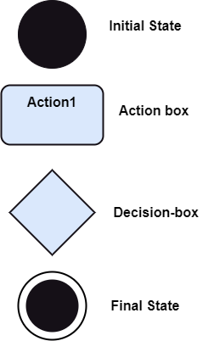

Why use Activity Diagram?
An event is created as an activity diagram encompassing a group of nodes associated with edges. To model the behavior of activities, they can be attached to any modeling element. It can model use cases, classes, interfaces, components, and collaborations.
It mainly models processes and workflows. It envisions the dynamic behavior of the system as well as constructs a runnable system that incorporates forward and reverse engineering. It does not include the message part, which means message flow is not represented in an activity diagram.
It is the same as that of a flowchart but not exactly a flowchart itself. It is used to depict the flow between several activities.

How to draw an Activity Diagram?
An activity diagram is a flowchart of activities, as it represents the workflow among various activities. They are identical to the flowcharts, but they themself are not exactly the flowchart. In other words, it can be said that an activity diagram is an enhancement of the flowchart, which encompasses several unique skills.
Since it incorporates swimlanes, branching, parallel flows, join nodes, control nodes, and forks, it supports exception handling. A system must be explored as a whole before drawing an activity diagram to provide a clearer view of the user. All of the activities are explored after they are properly analyzed for finding out the constraints applied to the activities. Each and every activity, condition, and association must be recognized.
After gathering all the essential information, an abstract or a prototype is built, which is then transformed into the actual diagram.
Following are the rules that are to be followed for drawing an activity diagram:
- A meaningful name should be given to each and every activity.
- Identify all of the constraints.
- Acknowledge the activity associations.

Example of an Activity Diagram
An example of an activity diagram showing the business flow activity of order processing is given below.
Here the input parameter is the Requested order, and once the order is accepted, all of the required information is then filled, payment is also accepted, and then the order is shipped. It permits order shipment before an invoice is sent or payment is completed.
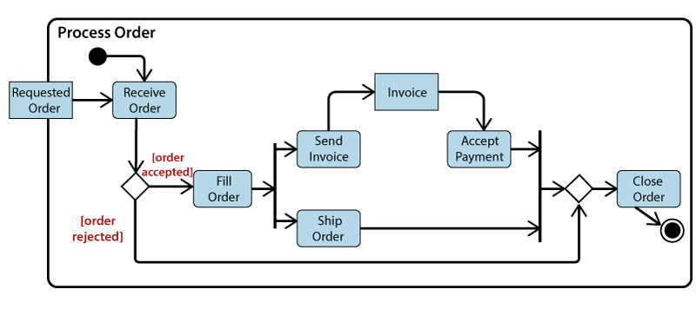

When to use an Activity Diagram?
An activity diagram can be used to portray business processes and workflows. Also, it used for modeling business as well as the software. An activity diagram is utilized for the followings:
- To graphically model the workflow in an easier and understandable way.
- To model the execution flow among several activities.
- To model comprehensive information of a function or an algorithm employed within the system.
- To model the business process and its workflow.
- To envision the dynamic aspect of a system.
- To generate the top-level flowcharts for representing the workflow of an application.
- To represent a high-level view of a distributed or an object-oriented system.

UML Timing Diagram
In UML, the timing diagrams are a part of Interaction diagrams that do not incorporate similar notations as that of sequence and collaboration diagram. It consists of a graph or waveform that depicts the state of a lifeline at a specific point of time. It illustrates how conditions are altered both inside and between lifelines alongside linear time axis.
The timing diagram describes how an object underwent a change from one form to another. A waveform portrays the flow among the software programs at several instances of time.
Following are some important key points of a timing diagram:
- It emphasizes at that particular time when the message has been sent among objects.
- It explains the time processing of an object in detail.
- It is employed with distributed and embedded systems.
- It also explains how an object undergoes changes in its form throughout its lifeline.
- As the lifelines are named on the left side of an edge, the timing diagrams are read from left to right.
- It depicts a graphical representation of states of a lifeline per unit time.
- In UML, the timing diagram has come up with several notations to simplify the transition state among two lifelines per unit time.

Basic concepts of a Timing Diagram
In UML, the timing diagram constitutes several major elements, which are as follows:
Lifeline
As the name suggests, the lifeline portrays an individual element in the interaction. It represents a single entity, which is a part of the interaction. It is represented by the classifier's name that it depicts. A lifeline can be placed within a "swimlane" or a diagram frame.
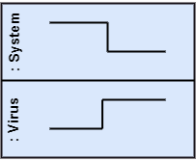
Lifelines representing instances of a System and Virus
State or Condition Timeline
The timing diagram represents the state of a classifier or attributes that are participating, or some testable conditions, which is a discrete value of the classifier.
In UML, the state or condition is continuous. It is mainly used to show the temperature and density where the entities endure a continuous state change.
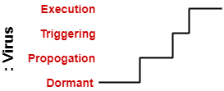
Timeline showing the change in the state of virus between dormant, Propagation, Triggering, Execution
Duration Constraint
The duration constraint is a constraint of an interval, which refers to duration interval. It is used to determine if the constraint is satisfied for a duration or not. The duration constraint semantics inherits from the constraints.
The negative trace defines the violated constraints, which means the system is failed. A graphical association between duration interval and the construct, which it constrains, may represent a duration constraint.
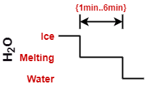
Ice should melt into the water in 1 to 6 mins.
Time Constraint
It is an interval constraint, which refers to the time interval. Since it is a time expression, it depicts if the constraint is satisfied or not. The constraints dispense its time constraints semantics.
The negative trace defines the violated constraints, which means the system is failed. The time constraint is represented by a graphical association between the time interval and the construct which it constrains.
The graphical association is mainly represented by a small line in between a time interval and an occurrence specification.
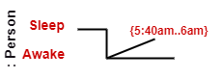
A person should wakeup in between 5:40 am, and 6 am
Destruction Occurrence
The destruction occurrence refers to the occurrence of a message that represents the destruction of an instance is defined by a lifeline. It may subsequently destruct other objects owned by the composition of this object, such that nothing occurs after the destruction event on a given lifeline. It is represented by a cross at the end of a timeline.
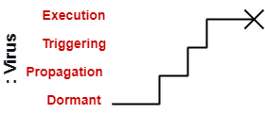
Virus lifeline is terminated

Example of a Timing Diagram
A timing diagram example of a medical domain that depicts different stages of Alzheimer's disease (AD) is explained below.
Since Alzheimer's is a very progressive fatal brain disease, it leads to memory loss and intellectual abilities. The reason behind this disease is yet to be discovered. It cannot be cured as well as one of the main reasons for rising death rates in the United States.
The doctor may require a diagnostic framework with three to seven-stage, such that its evolution may last for about 8 to 10 years. Also, in some cases, it lasts up to 20years from the time neuron starts changing.
The example given below constitutes timing for a seven-stage framework. The given example is just a UML diagram and should not be considered as a reference to medical research. The medical details are provided for you to better understand the UML diagram.
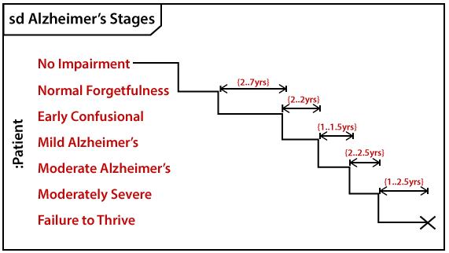
Following are the seven-stage Alzheimer disease framework explained below:
- No Impairment, Normal State
It is the stage where the memory and cognitive abilities look normal.
- Normal Aged Forgetfulness
It is mostly seen in people with an age group of 65 who experience subjective complaints of cognitive and/or functional difficulties, which means they face problems in recalling the name and past 5 to 10 years of history.
- Early Confusional, Mild Cognitive Impairment
It causes a problem in retrieving words, planning, organizing, objects misplacing as well as forgetting fresh learning, which in turn affects the surrounding.
- Late Confusional, Mild Alzheimer's
In this, a person forgets the most recent events and conversations. The person remembers himself and his family, but face problems while carrying out sequential tasks such as cooking, driving, etc. Its duration is about two years,
- Early Dementia, Moderate Alzheimer's
In this, the person cannot manage independently. He faces difficulty in recalling the past details and contact information. It lasts for about 1.5 years.
- Middle Dementia, Moderately Severe Alzheimer's
It leads to insufficient awareness about current events, and the person is unable to recall the past. It causes an inability in people to take a bath and dress up independently. It lasts for about 2.5 years approximately.
- Late or Severe Dementia, Failure to Thrive
It is severely limited intellectual ability. In this, a person either communicates through short words or cries, which leads health to decline as it shut down the body system. Its duration is 1 to 2.5 years.

Benefits of Timing Diagram
- It depicts the state of an object at a particular point in time.
- It implements forward and reverses engineering.
- It keeps an eye on every single change that happens within the system.

Drawbacks of Timing Diagram
- It is hard to maintain and understand.

